**Peterston-super-Ely Community Council** **Cyngor Cymuned Llanbedr-y-Fro**

**COUNCIL SUMMONS**

The next Meeting of Peterston-Super-Ely Community Council is to be held on the  
8th July 2024 at 7:30pm at the Village Hall. The meeting will be multi location.   
To attend remotely contact the Clerk by emailing [council@peterstonsuperely.org](mailto:council@peterstonsuperely.org)   
The following business will be transacted.

Yours sincerely,

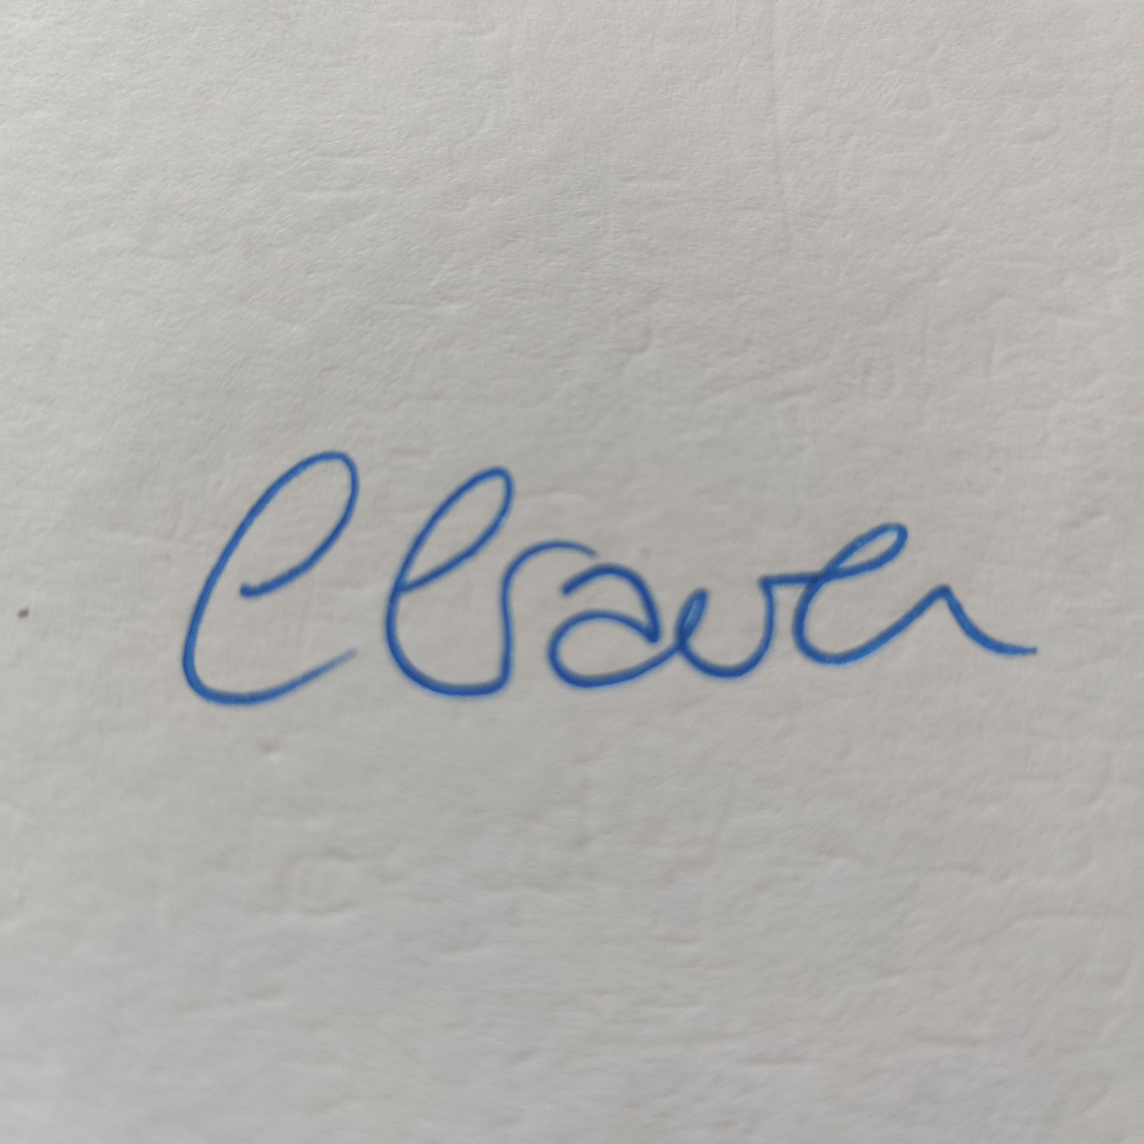  
Catherine Craven   
Clerk to the Council

**AGENDA**

* 1. Apologies for absence.
  2. Disclosures if Personal/Prejudicial Interest from Members.
  3. In person request from the public and press.
  4. Report from Vale of Glamorgan Councillor, Michael Morgan.
  5. **To approve** the minutes of the meetings held on the 10th June 2024 and review actions arising;
  6. **To note** correspondence:

1. Vale of Glamorgan Council
2. Planning Applications
3. One Voice Wales
4. Members of the Public
5. Neighbourhood policing team
6. Other organisations / bodies
   1. Councillor Reports
7. Highways (Cllr. Firth)
8. Assets and risk assessment (Cllr. Phillips)
9. Training Plan (Cllr. Phillips)
10. Churchyard fees (Cllrs. Meir/ Moody/Jones)
11. Annual Report (Cllr. Phillips)
12. Community Action Plan  
    (i) Mechanism for monitoring and progressing

(ii) How to ask for volunteers for the projects and depend on them

1. MUGA (Cllr. Cross/Drysdale  
   (i) Notes from Working Group

(ii) Drainage Work

(iii) A sports/publicity/volunteer event

* 1. Finance: **To approve**

1. Bank reconciliation
2. Payments due
3. First Quarter Budget Report
4. Arrangement for August payments